Employee: Conversation date: Supervisor: Time period:

This discussion gives us the opportunity to reflect and look forward together – with a focus on personal and career development. Good preparation, self-reflection and feedback are important factors for having a successful discussion with long-term impact. Feedback should be critical, development-oriented and appreciative.
- Status review

Looking back | What were the objectives, tasks and projects? How well were they executed?  What were last year’s highlights and challenges? Why?

Supervisor assessment |  | Employee comments on supervisor assessment
- We are on the right path, and today we will be looking towards the future together.
- We are not always on the right path, and we will be discussing that today.
In cases involving unsatisfactory performance and/or behaviour, an individual objective achievement plan is required, and HR partners need to be involved.

Outlook | What objectives, tasks and projects have been agreed on for the coming year?  Which contribution is expected?  A supplementary sheet on objectives, tasks and projects can be found here if needed.

- Personal development
Technical, methodological, personal and social competencies form the foundation of our success.
The social and leadership competencies outlined by ETH provide guidance on this point. They apply equally to supervisors and their employees.
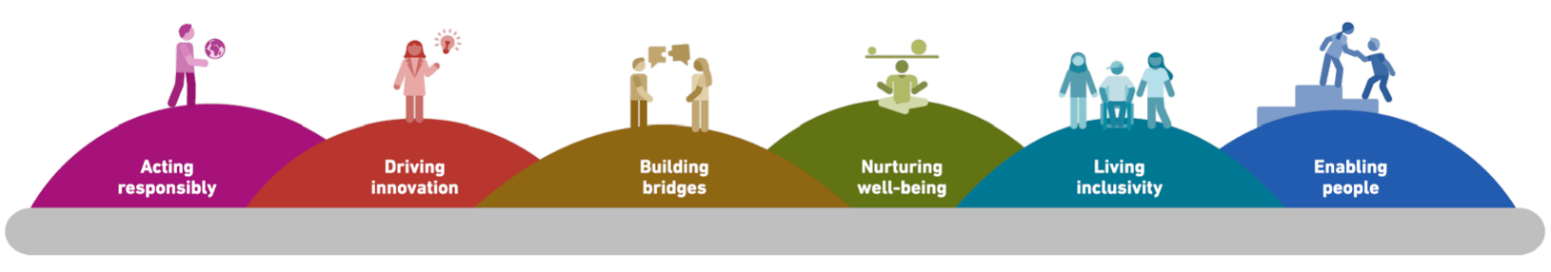

Competencies development | What competencies are your strengths (technical, methodological, personal, social)? Where is there room for improvement?  How can your supervisor provide support?

Potential | Where is potential, and how can it be unfolded in the coming years?  In which areas can more responsibility be taken to learn from it?

- Future collaboration

Here, employees can provide feedback to their supervisors.
What is appreciated about the collaboration? What should there be more of/less of?
How could the collaboration be improved in the future?

- Conclusion

Reflect on the discussion as a whole and close on a positive note.

Discussed
- Employee

- Supervisor

Additional remarks

