|  |
| --- |
|  |



[Title]

Rev1

[Subject]

Structural Engineering ….

June 2020

Acknowledgements

Thanks.

[Subject]

[Title]

Rev1

[Company]

Stefano-Franscini-Platz 5, 8093 Zurich, Switzerland

Phone: +41- XX XXX XX XX

Fax: +41- XX XXX XX XX

E-Mail: email@ethz.ch

June 2020

Abstract

Text

Keywords

Preferred citation style

Surname, N. (2016) Title, *Bachelor/Master Thesis*, **XXX**, IVT, ETH Zurich, Zurich.

Table of contents

1 Heading 3

1.1 Subheading 3

1.2 Subheading 3

2 Reference list 3

3 Glossary 3

A Appendix Heading 3

A.1 Appendix Subheading 3

List of tables

Table 1: Label 3

Table 2: Label 3

List of figures

Figure 1: Label 3

List of abbreviations

Text

List of symbols

Text

# Heading

Paragraph

Table 1: Label

|  |  |  |  |  |
| --- | --- | --- | --- | --- |
| Table heading | Table heading | Table heading | Table heading | Table heading |
| Table content | Table content | Table content | Table content | Table content |
|  |  |  |  |  |
|  |  |  |  |  |
| Source or notes. | | | | |

## Subheading

Paragraph[1]

### Subsubheading

Paragraph

## Subheading

* list item
* list item

|  |  |  |  |  |  |  |  |
| --- | --- | --- | --- | --- | --- | --- | --- |
| Table 2: Label | | | | | | | |
| Table header | Table header | | | | | | |
|  | Sub header | Sub header | Sub header | Sub header | Sub header | Sub header | Sub header |
| Table content | Content | Content | Content | Content | Content | Content | Content |
|  |  |  |  |  |  |  |  |
|  |  |  |  |  |  |  |  |
|  |  |  |  |  |  |  |  |
|  |  |  |  |  |  |  |  |
|  |  |  |  |  |  |  |  |
|  |  |  |  |  |  |  |  |
|  |  |  |  |  |  |  |  |
|  |  |  |  |  |  |  |  |
|  |  |  |  |  |  |  |  |
|  |  |  |  |  |  |  |  |
|  |  |  |  |  |  |  |  |
|  |  |  |  |  |  |  |  |
|  |  |  |  |  |  |  |  |
| Source and or notes. | | | | | | | |
|  | | | | | | | |

Figure 1: Label

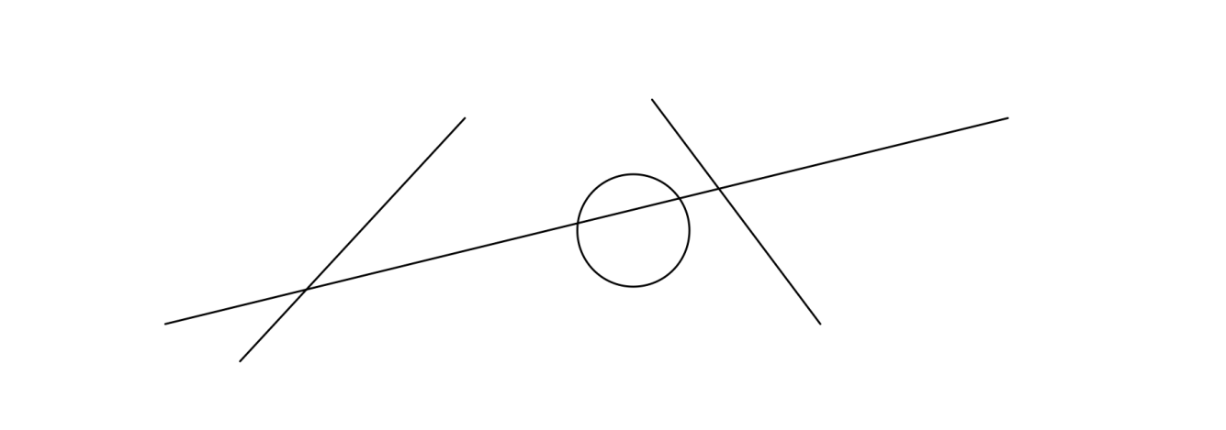

# Reference list

Arthur, P. and R. Passini (1992) *Wayfinding: People, Signs and Architecture*, McGraw Hill, New York.

Backhaus, N. and M. Steinemann (2002) Leitfaden für wissenschaftl. Arbeiten, *Schriftenreihe Anthropogeographie*, Geographisches Institut, Zurich University UZH, Zurich.

Chapman, M and C. Wykes (1996) *Plain Figures*, HMSO, London.

Cleveland, W.S. (1994) *The Elements of Graphing Data*, Hobart Press, Summit.

Dudenredaktion (Hrsg.) (2014) *Duden: Die deutsche Rechtschreibung*, Dudenverlag, Mannheim.

ETHZ CC (2016) Corporate design, https://www.ethz.ch/services/en/service/communication/corporate-design.html, ETH Zurich Corporate Communications, Zurich, May 2016.

Gowers, E. (1986) *The Complete Plain Words*, revised by S. Greenbaum and J. Whitcut, HMSO, London.

RSETHZ (2004a) Procedure to address allegations of research misconduct at the ETH Zurich (RSETHZ 415), Rechtsdienst ETH Zurich, Zurich.

RSETHZ (2004b) Disciplinary code of the Swiss Federal Institute of Technology Zurich (RSETHZ 361.1), Rechtsdienst ETH Zurich, Zurich.

RSETHZ (2007) Guidelines for Research Integrity and Good Scientific Practice at the ETH Zurich (RSETHZ 414), Rechtsdienst ETH Zurich, Zurich.

Schweizerische Bundeskanzlei (1996) *Leitfaden zur sprachlichen Gleichbehandlung*, EDMZ, Bern.

Schweizerische Bundeskanzlei (1998) *Leitfaden zur Neuregelung der deutschen* Rechtschreibung, EDMZ, Bern.

Tufte, E. (1983) *The Visual Display of Quantitative Information*, Graphics Press, Cheshire.

Wilkinson, L. (1999) *The Grammar of Graphics*, Springer, Heidelberg.

# Glossary

Text

# Appendix Heading

## Appendix Subheading

### Appendix Subsubheading

1. Footnote.