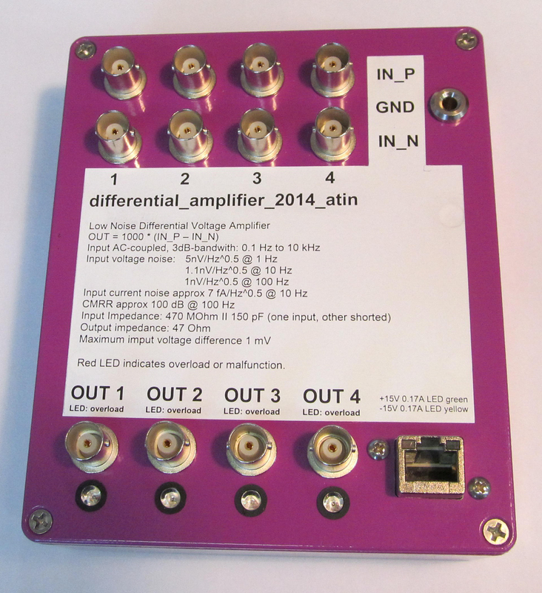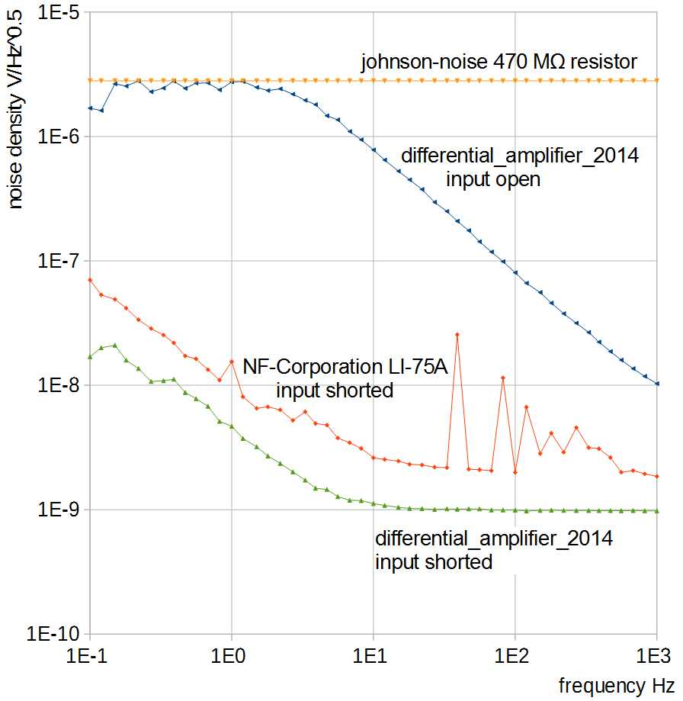
Left: top view of the 4-channel differential amplifier. Right: Input voltage noise measurements. The commercially available amplifier LI-75 is shown for comparison.

- extraordinarily low input voltage noise
- internal supply voltage very well stabilized, nearly no powerline noise is coupled to the input.
- 4 channels, AC coupled
- typical application: measurement of a hall-bar voltage

Specifications | Range | Unit / Conditions
Input voltage noise | 5 (3 optional) | nV/Sqrt(Hz) @ 1Hz
 | 1.1  1  1 | nV/Sqrt(Hz) @ 10Hz  nV/Sqrt(Hz) @ 100Hz  nV/Sqrt(Hz) @ 1KHz
Input current noise  Input difference voltage  CMRR  Input Impedance  Voltage Gain  Power consumption | 7  1  100  470  1000  ± 15 V, 0.17 A | fA/Sqrt(Hz) @ 10Hz  mV max  dB @ 100 Hz  MOhm, AC coupled  suitable power supply included

