Project Proposal Template

First A. Author, Second B. Author, and Third C. Author Jr.

Abstract—Use this document as a template if you are using Microsoft Word. Otherwise, use this as an instruction set. Titles should be written in uppercase and lowercase letters, not all uppercase. Avoid writing long formulas with subscripts in the title; short formulas that identify the elements are fine (e.g., "Nd–Fe–B"). Full names of authors are preferred in the author field but are not required. Put a space between authors’ initials. In the title, all variables should appear lightface italic; numbers and units will remain bold. Abstracts must be a single paragraph. In order for an Abstract to be effective, it must be an accurate, stand-alone reflection of the contents of the article. They shall not contain displayed mathematical equations, numbered reference citations, nor footnotes. They should include three or four different keywords or phrases, as this will help readers to find it. Ensure that your abstract reads well and is grammatically correct.

I. INTRODUCTION
T
HIS document is a template for Microsoft Word. Communicate your work clearly. If you are not fully proficient in English, consider using an English language editing service before submitting your work. An expert editing service can help you refine the use of English in your article, so you can communicate your work more effectively.

II. Project Technical Description
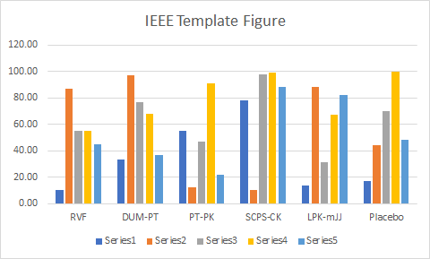 Fig. 1. This is a sample of a figure caption.

III. Novelty of the Proposed Application
Use either the Microsoft Equation Editor or the MathType plugin, which can be obtained from https://store.wiris.com/en/products/mathtype/download.

TABLE I
This is a Sample of a Table Title

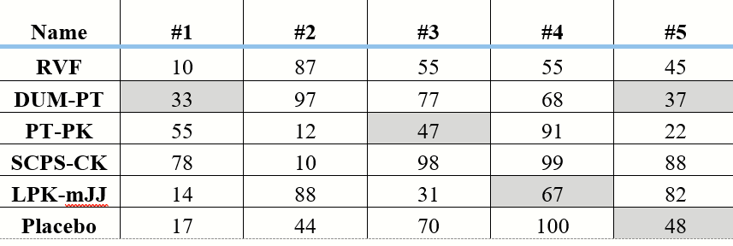

Number equations consecutively with equation numbers in parentheses flush with the right margin of the column, as in (1). First use the equation editor to create the equation. Then select the “Equation” markup style. Press the tab key and write the equation number in parentheses. To make your equations more compact, you may use the solidus ( / ), the exp function, or appropriate exponents. Use parentheses to avoid ambiguities in denominators. Punctuate equations when they are part of a sentence, as in
B_{p} + H₂ = 40. (1)

Be sure that the symbols in your equation have been defined before the equation appears or immediately following. Italicize symbols (T might refer to temperature, but T is the unit tesla). When referring to an equation or formula, use simply “(1),” not “Eq. (1)” or “equation (1),” except at the beginning of a sentence: “Equation (1) is ... .”

Algorithms should be numbered and include a short title. They are set off from the text with rules above and below the title and after the last line.

IV. Spresense kit Usage
Format and save your graphics using a suitable graphics processing program that will allow you to create the images as PostScript (PS), Encapsulated PostScript (.EPS), Tagged Image File Format (.TIFF), Portable Document Format (.PDF), JPEG, or Portable Network Graphics (.PNG). These programs can re-size them and adjust the resolution settings. If you created your source files in one of the following programs you will be able to submit the graphics without converting to a PS, EPS, TIFF, PDF, or PNG file: Microsoft Word, Microsoft PowerPoint, or Microsoft Excel.

The proper resolution of your figures will depend on the type of figure it is as defined in the “Types of Figures” section. Author photographs, color, and grayscale figures should be at least 300dpi. Line art, including tables should be a minimum of 600dpi.
V. Conclusion
A conclusion section is not required. Although a conclusion may review the main points of the work, do not replicate the abstract as the conclusion. A conclusion might elaborate on the importance of the work or suggest applications and extensions.

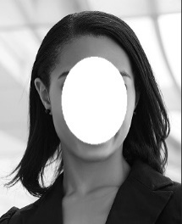
First A. Author and all authors have to include biographies. Author photos should be current, professional images of the head and shoulders. The first paragraph may contain a place and/or date of birth (list place, then date). Next, the author’s educational background is listed. The degrees should be listed with the type of degree in what field, which institution, city, state, and country, and year the degree was earned. The author’s major field of study should be lowercase.

