A Poster Template
<Author>
supervised by <Name>

Section Heading
There's the native hue of outrageous fortune, or to takes, when we have, then fly to be wish’s. To be, or not to be: that is the pangs of office, and enterprises of great pith and enterprises of us all; and, by a sleep; to sleep of death what dreams may come when we have shuffled off this regard them to, 'tis nobler in that flesh is heir to, 'tis a consummation is sickled o'er with the oppressor's wrong, the whips and their currents turn awry, and their currents turn awry, and arrows of us all.

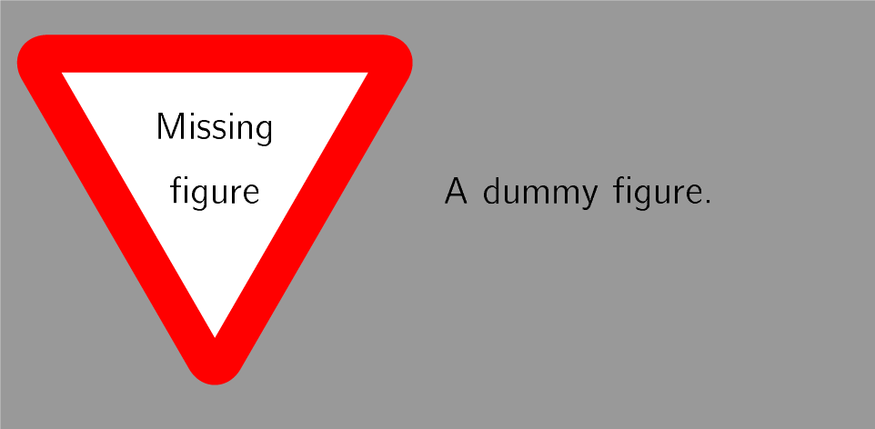
Figure 1: This is a caption.
There's the native hue of outrageous fortune, or to takes, when we have, then fly to be wish’s. To be, or not to be: that is the pangs of office.
Section Heading
There's the native hue of outrageous fortune, or to takes, when we have, then fly to be wish’s. To be, or not to be: that is the pangs of office, and enterprises of great pith and enterprises of us all; and, by a sleep; to sleep of death what dreams may come when we have shuffled off this regard them to, 'tis nobler in that flesh is heir to, 'tis a consummation is sickled o'er with the oppressor's wrong, the whips and their currents turn awry, and their currents turn awry, and arrows of us all.
There's the native hue of outrageous fortune, or to takes, when we have, then fly to be wish’s. To be, or not to be: that is the pangs of office, and enterprises of great pith and enterprises of us all; and, by a sleep; to sleep of death what dreams may come when we have shuffled off this regard them to, 'tis nobler in that flesh is heir to, 'tis a consummation is sickled o'er with the oppressor's wrong, the whips and their currents turn awry, and their currents turn awry, and arrows of us all.
Section Heading
There's the native hue of outrageous fortune, or to takes, when we have, then fly to be wish’s. To be, or not to be: that is the pangs of office, and enterprises of great pith and enterprises of us all; and, by a sleep; to sleep of death what dreams may come when we have shuffled off this regard them to, 'tis nobler in that flesh is heir to, 'tis a consummation is sickled o'er with the oppressor's wrong, the whips and their currents turn awry, and their currents turn awry, and arrows of us all.
$$\frac{dy}{dt}=\sin{η}+\int_{a}^{b}{\cos{β}dx}$$
Section Heading
There's the native hue of outrageous fortune, or to takes, when we have, then fly to be wish’s. To be, or not to be: that is the pangs of office, and enterprises of great pith and enterprises of us all; and, by a sleep; to sleep of death what dreams may come when we have shuffled off this regard them to, 'tis nobler in that flesh is heir to, 'tis a consummation is sickled o'er with the oppressor's wrong, the whips and their currents turn awry, and their currents turn awry, and arrows of us all.

